**Hermes - Electronic Speed Controller running Field-Oriented Control**

ECE/BME 499 - Design Project II

June 20, 2023



**Group ID:**

**Faculty supervisor:**

**Co-supervisor (if any):**

**Team Information:**

|  |  |  |
| --- | --- | --- |
| S. No. | Name | V Number |
|  | Aman Nijjar | V00865405 |
|  | Ava Newert |  |
|  | Evan Miere |  |
|  |  |  |
|  |  |  |
|  |  |  |



Contents

I Objectives 1

II Introduction 1

III Literature Survey & Specifications 1

IV Team Duties & Project Planning 1

V Milestone & Progress Made 2

VIII Summary & Future Work 2

References 2

# I Objectives

* Please write objectives of the project in bullet points
* Please do include objectives specific to first progress report such as team member roles, anticipated milestones etc.

# II Introduction

In the Introduction section, please clearly mention the problem definition, the scope of work and the goals. Also, please write briefly about why you chose the project and the social impact this project has. Read the code of ethics of Engineers and Geoscientists BC (EGBC) and relate to the relevant principles that can be applied to this project. Finally, a brief paragraph about the potential user base would add value.

# III Literature Survey & Specifications

In this section, please do a review of literature focussing on different solutions for the problem you are trying to solve. You are also expected to justify the choice of your solution (method/approach) by comparing capabilities, cost and ease of use with existing solutions.

As an engineering team, each group is expected to come out with details on how the components ratings were decided. Please note, in case equations have to be used please use equation editor and number the equations in sequence as shown below.

$I_{dc}=\frac{V_{dc}}{R_{1}+R_{2}}$ (1)

Also, please do cite your references using numbers within square brackets [1], [2] and paraphrase from your reference articles. It is not acceptable to copy and paste content from references.

# IV Team Duties & Project Planning

In this section, please give a clear description of roles of each member in the team. It is important to come up with precise deliverables for each team member. Ideally, each team member should have identical load sharing especially in terms of critical contributions to the success of the project. Therefore, there must be at least one deliverable for each member without which the project cannot succeed.

The section of the report should also indicate exactly what is required to achieve these deliverables successfully. The inputs needed could be a deliverable from another member of the team.

Further, the project is expected to be completed before August. Hence, it is significant to identify the potential bottlenecks foreseen in completing the project on time. Also, teams can write in brief about the strategies to be followed in case their plan A fails.

# V Milestone & Progress Made

In this section, groups are expected to provide milestone activities and dates for the project.

Also, as an indicator of progress, each group is expected to enclose details of the work done until the 24th June. As a part of progress report, if figures have to be included, it is preferable each graph/image/chart uses the template of the sample graph shown in Fig. 1. That is, the axes must be clearly labelled. It is preferable to have a legend. Font size should be readable in print version of the report. And a caption must be provided explaining what the image is about.

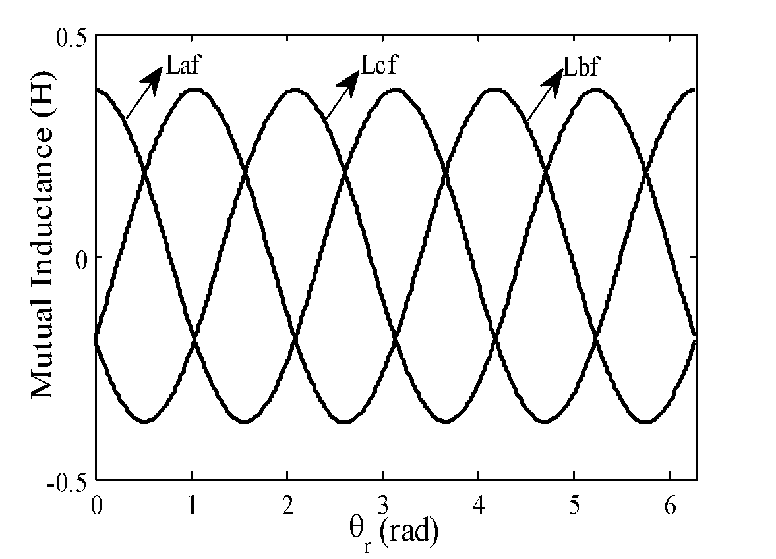

Fig. 1. A sample graph with labels along x, and y axes. The image has multiple signals represented using different types of lines and identified using a text.

# VIII Summary & Future Work

In this section of the report, the groups can summarize the problem objective, the reason for the method selected and the project plan.

# References

[1]

[2]